|  |
| --- |
| **1 – Concept Map – Business Domain** |

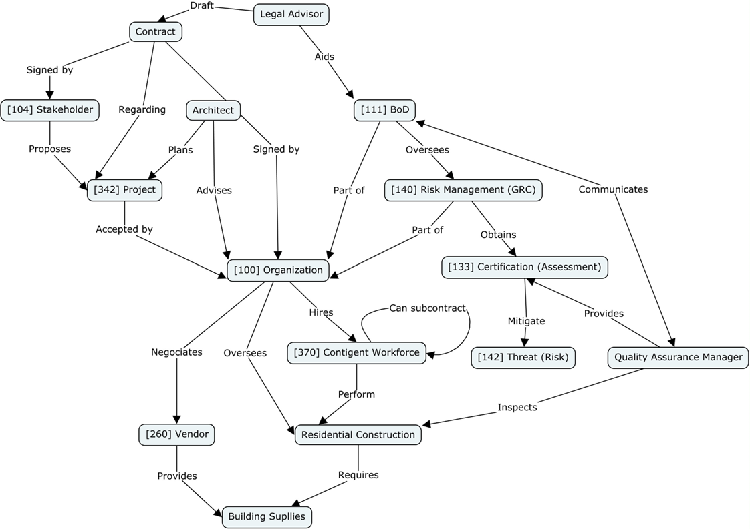

|  |  |  |
| --- | --- | --- |
| **Concept** | **Definition (one sentence per concept)** | |
| [100] Organization | group of people that has its own functions with responsibilities, authorities and relationships to achieve its objectives. | |
| [104] Stakeholder | Individuals, groups or organizations holding Concerns for the System of Interest. | |
| [111] BoD | Group of people who have ultimate accountability for the whole organization. | |
| [133] Certification (Assessment) | The provision by an independent body of written assurance (a certificate) that the product, service or system in question meets specific requirements. | |
| [140] Risk Management (GRC) | Coordinated bodies to direct and control an organization regarding risk. | |
| [142] Threat (Risk) | Potential cause of an unwanted incident, which can result in harm to a system or organization. | |
| [260] Vendor | 3rd-party service provider, separate from the Company, that offers something for sale. | |
| [342] Project | Temporary endeavour to achieve one or more defined objectives. | |
| [370] Contingent Workforce | Independent contractors and consultants, hired for temporary projects where they lend their expertise to one or multiple organizations. | |
| Architect | [2] Architects design the buildings and spaces around us. | |
| Building Supplies | [4] Building Supplies are materials used for construction. | |
| Contract | [5] Contract between two or more parties that creates a legal obligation. | |
| Legal Advisor | [2] Legal advisors provide companies with guidance in matters relating to law. | |
| Quality Assurance Manager | [2] A Quality Assurance Manager ensures that all of a company’s services and activities meet and maintain set standards. | |
| Residential Construction | [3] Residential Construction is the process of constructing a house, apartment building, or similar residential building. | |
| **2 – Description of the business domain and its context** | |

Residential construction is a sector within the construction industry that addresses the human need for shelter and accommodation. It fulfils the growing demand for housing as populations expand and urbanization intensifies. In this domain, businesses offer a range of products and services, including the construction of single-family homes, townhouses, condominiums, and apartment complexes.

Products in residential construction encompass various types of housing structures, ranging from affordable housing units to luxury homes. These products are tailored to meet the diverse needs and preferences of homeowners, including factors such as size, design, amenities, and energy efficiency.

Services provided by **residential construction** **organizations** cover the entire construction process, from initial planning and design to construction management and post-construction services. This includes architectural design, engineering, site preparation, construction labor, project management, and **quality assurance**.

In terms of business models, residential construction firms typically operate using a project-based model, where they secure **contracts** for specific construction **projects**. Some firms also engage in speculative homebuilding, where they construct homes without a specific buyer in mind, aiming to sell them upon completion.

**Stakeholders** in residential construction include homeowners, developers, construction companies, subcontractors, suppliers, regulatory authorities, and financial institutions providing funding for construction projects.

Governance, risk, and compliance are critical issues in residential construction. Corporate governance ensures that construction firms are managed and directed effectively, considering the interests of shareholders, employees, and other **stakeholders**. Key issues include transparency, accountability, and ethical behavior.

**Risk management** is essential due to the inherent uncertainties in construction projects, including cost overruns, delays, and quality issues. Mitigating risks involves thorough planning, monitoring, and proactive problem-solving throughout the construction process.

Compliance with building codes, regulations, and industry standards ensures residential construction projects’ safety, quality, and legality. Failure to comply can result in legal penalties, project delays, and reputational damage.

Key performance indicators (KPIs) play a vital role in monitoring and evaluating the performance of **residential construction** **projects**. These may include metrics such as project cost, schedule adherence, quality defects, customer satisfaction, and safety incidents.

In terms of IT-related KPIs, residential construction firms may focus on metrics related to project management software usage, such as utilization rates, software adoption rates, and data accuracy. Additionally, KPIs related to information security, such as cybersecurity incidents and data breaches, are increasingly important in safeguarding sensitive project data and client information.

|  |
| --- |
| **3 – Main challenges in relation to the use** **of Artificial Intelligence** |

One of the primary challenges in implementing Artificial Intelligence (AI) in residential construction is the industry's traditional resistance to change. Construction has historically been a conservative sector, relying heavily on established practices and methods. Introducing AI requires a shift in mindset and culture to embrace new technologies and processes. Resistance can come from various stakeholders, including construction workers, project managers, and company leadership. Overcoming this challenge involves effective change management strategies, education, and demonstrating the tangible benefits of AI in improving project outcomes, efficiency, and safety.

Another significant challenge is the complexity and variability of residential construction projects. Unlike manufacturing or assembly line processes, construction projects are highly dynamic and subject to numerous variables, such as weather conditions, site-specific challenges, and evolving client preferences. AI algorithms need to adapt to these complexities to provide accurate predictions and recommendations. Achieving this requires robust AI models that can analyze large datasets and account for uncertainties in the construction process. Additionally, integrating AI into existing project management systems and workflows without disrupting ongoing projects is a logistical challenge that requires careful planning and coordination.

There are also concerns regarding the ethical implications of AI in residential construction. AI algorithms may inadvertently perpetuate biases or errors, leading to unfair outcomes or safety risks. Ensuring the ethical use of AI involves addressing issues such as algorithmic bias, transparency, and accountability. Additionally, there are legal considerations, including liability for decisions made based on AI-generated recommendations and compliance with data privacy regulations. Overcoming these challenges requires industry-wide collaboration, investment in research and development, and the development of standards and guidelines for the ethical and responsible use of AI in residential construction. By addressing these challenges, AI has the potential to revolutionize residential construction, driving efficiency, innovation, and sustainability in the industry.

|  |
| --- |
| **4 – Main challenges in relation to the use of IT** |

The industry's fragmentation and dominance by small to medium-sized businesses often mean limited investment resources in IT infrastructure and software. Many firms still need to rely on outdated systems or manual processes, hindering efficiency and productivity. Integration issues and a lack of solutions can lead to inefficiencies in project management, scheduling, and communication.

Cybersecurity is another significant concern. As construction processes become increasingly digitized and reliant on cloud-based systems, firms become more vulnerable to cyber threats. Data breaches, ransomware attacks, and phishing scams can compromise sensitive project data and client information, leading to significant financial and reputational damage. Ensuring robust cybersecurity measures and providing adequate training for employees to recognize and respond to security threats are essential to protect against these risks. However, many construction companies may lack the expertise and resources to implement these strategies effectively.

The rapid pace of technological change presents a challenge for residential construction firms. With new IT solutions constantly emerging, companies must navigate through a sea of options to find those most suitable for their needs. Lack of expertise in evaluating and implementing IT solutions can result in costly mistakes.

|  |
| --- |
| **5 – References** |

1. <https://www.goconstruct.org/why-choose-construction/how-does-construction-work/> accessed on 1/5/2024
2. <https://www.goconstruct.org/construction-careers/browse-all-job-roles/> accessed on 1/5/2024
3. <https://en.wikipedia.org/wiki/Home_construction> accessed on 1/5/2024
4. <https://en.wikipedia.org/wiki/Building_material> accessed on 1/5/2024
5. <https://ironcladapp.com/journal/contracts/what-is-a-contract/> accessed on 1/5/2024